Guelph Minor Baseball Association Inc.

5C – 100 Crimea Street, Guelph, ON N1H 2Y6
Phone: (519) 836-8771 Fax: (519) 836-7309
Website: www.gmba.ca * E-mail: office@gmba.ca

Board meeting – November 7, 2019 at GMBA office.
Meeting called to order at 7:01 pm

Present: Heather MacPherson, Donato, Jim, Stef, Adam, Ryan, Jeff, Iain, Cory, Richard, Dave, Sean, Libby, Vicki, Jessica, Koko, Heather Sutcliffe

Approval of Agenda- Motioned by Adam, Seconded by Cory. Approved.
Minutes- Motioned by Sean, Seconded by Koko. ICBA report unclear. Friendly amendment to clarify
Carried.

Declaration of Conflicts- new addition to the agenda.
Important that in small organizations, conflicts can arise when there is a benefit from a decision that this board makes. Jeff will work on a policy that helps to clarify. Consider self, family, team.
Conflict can be declared personally as well as initiated by another board member to ensure that we as the board are acting in the best interest of the organization.

Conflicts identified:
-Libby Mallot and Kevin Caron re honorariums
-Sean Staniforth, Libby Mallot - Tournaments

Board Terms and Roles-
Role of treasurer was not appointed at the AGM. This role is a member of the board, but is not a voting director, but role can be appointed by the board.

Motion: To appoint Donato as the treasurer for 2019/2020 season. Motion put forward by Vicki, seconded by Cory. Passed.

President Report- Jeff Hoffman
Terms-
Every year, 1/3 of the board has their roles come to an end. This approach allows for succession planning and stability of both the board and the day to day operation of the organization.

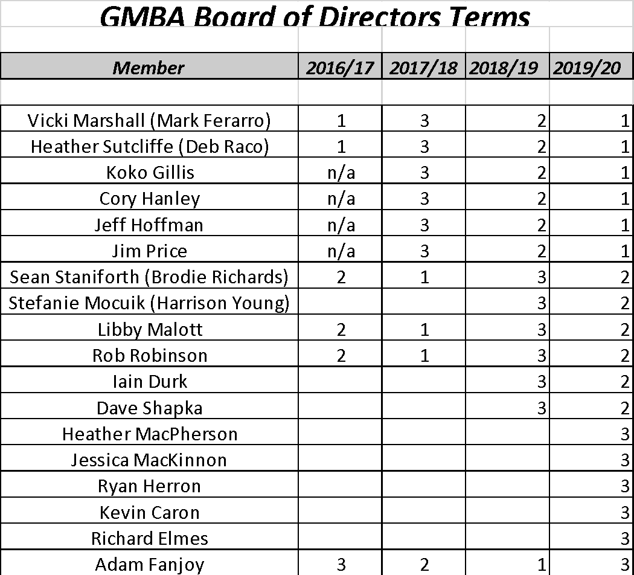

Roles-
Main buckets of operational focus will be chaired by Executive members and will have board members assigned to each of the roles under the area of focus.

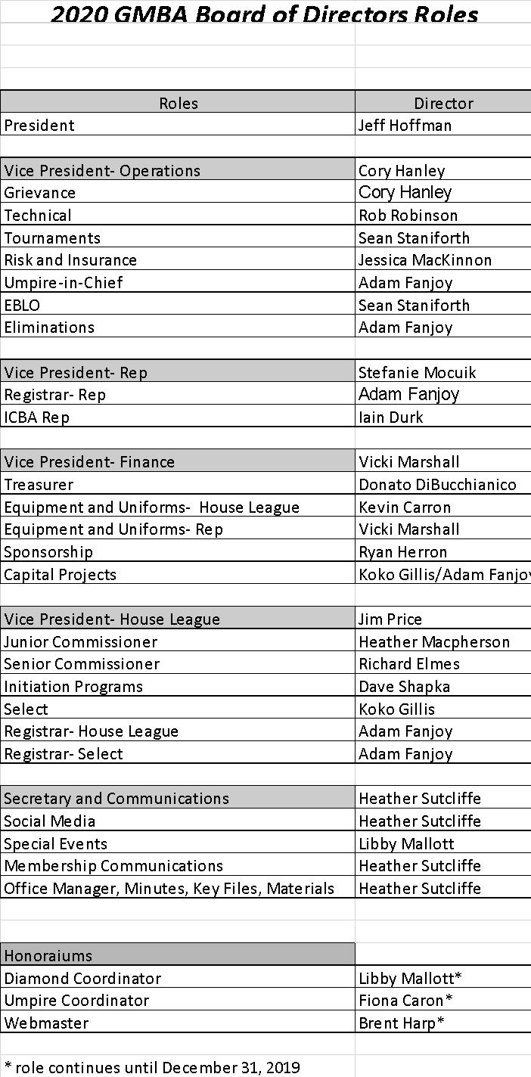

Insurance:
- 2 ways that the association is insured.
Baseball Ontario Insurance Program
- Insurance policy covers sports liability, errors and omissions (directors insurance) for players during game, coaches and umpires.
- Covers much of our on-field activities.
*see full policy attached for reference

- St. Andrews Insurance Policy for Commercial Property
- Covers fire, theft, cyber insurance
- Discussion re value of having insurance review with the board of directors to clarify.
ACTION ITEM: Vicki will reach out to Mike Inglis with St Andrews with request to attend future board meeting for an insurance overview.

Priorities:
Increasing membership
Player development- Houseleague, Select and Rep
Coach Development- Houseleague, Select and Rep
EBLO program development
Openness and transparency
Enhanced Business processes and systems
Updated budget for 2020
Initiation Program Enhancement

Areas of priorities will be worked into each committee work plan.

Open Items:

Sandlot- Adam
Tournament Management Proposal reviewed (see attached)
Consulting Fee would be 16+ team tournament $1200, 12 teams $800, less than 12 teams TBD. If there is no margin for profit from tournaments, tournaments would be cancelled.

Tournaments drive profit that fund out scholarship program.
Volunteer needs for tournament weekends are significant and in past years, it has been a core group of 5 or 6 people.
Benefits to community through sponsorships and hotel stipends will continue to flow to GMBA.
$750 per tournament in scholarship funds. $530 back to the association.

Motion: To accept Sandlot baseball as the tournament management company for Rival Series and Elimination for the 2020 season. Motioned by Adam- seconded by Jim
Passed.

Marden Clinics-
Sandlot has invoiced for $6000, costs have been covered for Marden rental. GMBA has not lost money on clinics, but there is potential for income stream from clinics moving forward.
Initial session had some issues identified, week 2 had corrective action and this session went better.
Tuesdays sessions were over capacity at 46 registrants, Saturday has lower registration at 36.

Elimination Tournaments- Adam
GMBA/Guelph has been granted the elimination tournaments for the 2020 and 2021 seasons.

50/50 unclaimed prize
Prize must sit in trust for 6 months to be able to allow for the potential winner to come forward. If prize goes unclaimed, proceeds of 50/50 event will need to be donated to a charity of our choice.

Cory’s team is the one that ran the 50/50 and is really interested in helping the association decide where the funds will go. Intention is to donate to organizations that will support kids in playing baseball to help with opportunities.
-possible organizations, Jumpstart, Make a Wish, Guelph Children’s Foundation

ACTION: Donato will investigate if it can be donated in one lump sum or if it could be donated in pockets of money to different organizations.

50/50 opportunities
Last year we started with 2 dates and ended up with 7 dates total.
3 have been given out- 2 to minor peewee, and 1 to minor rookie.
Donato has in the past sent emails out to teams and it is a first come first served approach.
Easier to assign and coordinate games in advance, last minute opportunities are more difficult.

Remaining game is December 14/19 vs Kitchener Rangers 2 pm game.
Libby to take the lead on this game as a board sanctioned event.
Ticket vouchers to be made available to be sold to association. Adam to work with Libby on this.

Proceeds of 50/50 will be added to the capital improvement budget.

Investigation Process- Cory
Based on past investigations and situation during the 2019 playing season, an incident regarding coach behaviour resulted in robust discussion among the board regarding the need for a new process.
Cory to continue to work on process. Open item.

Goal line Migration- Adam
Transition has been made to the new platform, with go live mid November.
Mobile friendly user interface to help with better family/player experience.

ICBA AGM
Constitutional changes- summary
-pass through release turnaround time is now 48 hours from 7 days
-players that tried out for EBLO teams in their own centre who are cut from teams would have an open release- defeated
-playoff tournaments will be now follow OBA format with a predetermined ICBA seeding.
-code of conduct – removed from ICBA as this will be done as part of central registration for players over 18, parents, coaches and umpires.

Iain will be the new ICBA rep.

Diamond Improvements- Koko
-opportunities to improve facilities for GMBA
-brought up a few years ago, and wish list was created.
*Brant ave has been identified as a potential opportunity for improvement - backstop

Mosquito and PeeWee diamonds have opportunities
*Joe Kaine accessibility, extension of 1st/3rd baselines for safety - communication to go to other associations regarding parking on the side streets with alternative accessible access
*Eramosa and York road- fences would help keep play live
-Westminster Woods- mound is not properly aligned, mound wound would be intensive, 1st and 3rd base lines would need to be repainted and a simpler fix
-curling club- is this an opportunity? City has decommissioned these diamonds.
-Norm Jary 1 extending fences from 1st base and dugouts.
-University Village- pathway from the parking lot to the diamond
-enclosed dugouts

Relationship with City of Guelph-
Libby meets with the city 1 x per year and will take things forward from coaches.
Debrief in November to help better understand priorities for the coming year.
2019 did not see much in terms of diamond improvements.
City is very excited regarding opportunities for eliminations

ACTION ITEM: Priority list to be established and discussed with the city

Honorariums: Jeff
Currently honorariums are paid for 3 positions- diamond coordinator, umpire coordinator, and webmaster as these roles require a significant amount of dedicated time to support the operation of GMBA.

ACTION: Board members to consider roles and discuss at the next meeting.

Budget:
Donato will schedule a budget planning meeting with executive and will be open to other board members

Other Business:
Minor Bantam T2
Final budget was late getting back to parents in mid October, revisions needed to be made and payments collected, additional challenges around signing officers.
Finances are now resolved and accounting is complete.
Next steps: Rep committee to work with the coach to ensure that financial policies are following for the coming season.

January 2020 meeting- moved to January 9, 2020.

July 23-27, 2020 will be the Elimination Tournament with a significant need for volunteers to help this event run smoothly and welcome teams to our community. Tournament will also be hosted by Milton.
24 teams are expected.
6 at 4pm, 6 at 7 pm on Thursday
6 games at 10, 1 and then schedule slows down on Friday.

Board Apparel
$2000 credit with SportZone that will be applied to board apparel.
Vicki to source 2 options and an email vote will be held to determine what will be ordered.

OBA AGM will be held in Guelph over the weekend of November 16.
Agenda is listed on the OBA website, please attend as you are able.

Meeting adjourned at 9:27 pm

